## Functional Specification

### Common module

#### Use Case Diagram

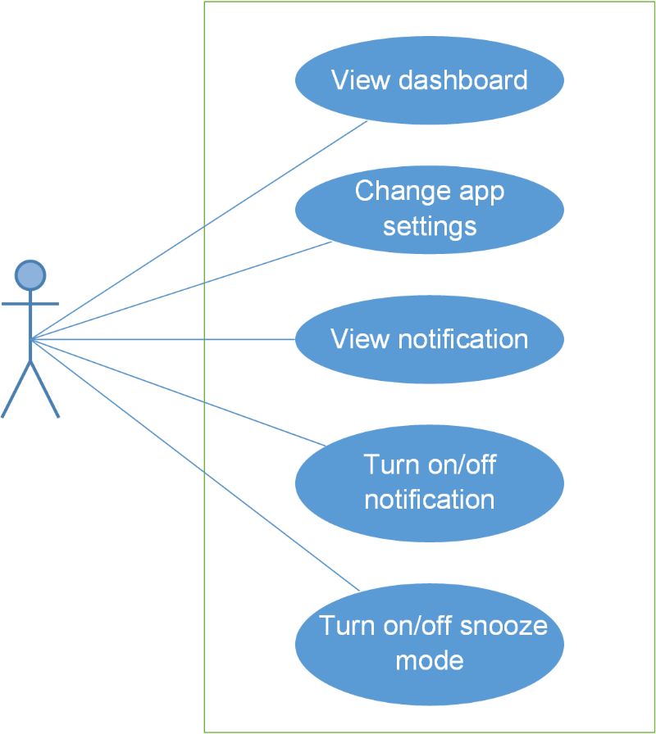

#### Use Case Specification

##### UC001: View dashboard

**Main Success Scenario:**

|  |  |  |
| --- | --- | --- |
| **Step** | **User** | **System** |
| 1 | Enters Bus lover app | Displays dashboard screen |

##### UC002: Change app settings

**Main Success Scenario:**

|  |  |  |
| --- | --- | --- |
| **Step** | **User** | **System** |
| 1 | Enters Bus lover app | Displays dashboard screen |
| 2 | Taps “Menu” button then tap “Settings” button | Displays Settings screen |
| 3 | Taps “Ngôn ngữ”/ “Nền”/ “Giao diện” dropdown then chooses any item in list | The information of “Ngôn ngữ”/ “Nền”/ “Giao diện” field is changed |
| 4 | Taps “Nhắc nhở khi xe buýt được chọn ở cách điểm dừng xe buýt gần nhất với bạn là X km”/ “Nhắc nhở về xe buýt được chọn mỗi X phút” then inputs number | The information of “Nhắc nhở khi xe buýt được chọn ở cách điểm dừng xe buýt gần nhất với bạn là X km”/ “Nhắc nhở về xe buýt được chọn mỗi X phút” field is changed |
| 5 | Taps “Tắt tất cả nhắc nhở”/ “Tắt tất cả thông báo" button | “Tắt tất cả nhắc nhở”/ “Tắt tất cả thông báo" button changes status |
| 6 | Taps Done button | Saves all edited information and move to Dashboard screen. |

**Alternative Scenario:**

|  |  |  |
| --- | --- | --- |
| **At Step** | **User** | **System** |
| 3 | Taps Done button | Nothing is changed and system moves to Dashboard screen |

**Exceptions:**

|  |  |  |
| --- | --- | --- |
| **At Step** | **User** | **System** |
| 4 | Inputs 0 into “Nhắc nhở khi xe buýt được chọn ở cách điểm dừng xe buýt gần nhất với bạn là X km”/ “Nhắc nhở về xe buýt được chọn mỗi X phút” field then taps Done button | Returns popup with Error message “Xin vui lòng nhập số lớn hơn 0.” |

##### UC001: View notification

**Main Success Scenario:**

|  |  |  |
| --- | --- | --- |
| **Step** | **User** | **System** |
| 1 | Enters Bus lover app | Displays dashboard screen |
| 2 | Taps Notification button | Displays Notification slide. |

**Alternative Scenario:**

|  |  |  |
| --- | --- | --- |
| **At Step** | **User** | **System** |
| 2 | Taps Done button | Nothing is changed and system moves to Dashboard screen |

##### UC003: Turn on/off notification

**Main Success Scenario:**

|  |  |  |
| --- | --- | --- |
| **Step** | **User** | **System** |
| 1 | Enters Bus lover app | Displays dashboard screen |
| 2 | Taps Ring button | Displays Notification slide. |
| 3 | Taps the switch (into off) | Button is changed status into OFF and all notification are hidden and turned off. |

**Alternative Scenario:**

|  |  |  |
| --- | --- | --- |
| **At Step** | **User** | **System** |
| 3 | Taps the switch (into on) | Button is changed status into ON and notification are turned on. |

##### UC004: Turn on/off snooze mode

**Main Success Scenario:**

|  |  |  |
| --- | --- | --- |
| **Step** | **User** | **System** |
| 1 | Enters Bus lover app | Displays dashboard screen |
| 2 | Taps Menu button | Displays menu |
| 3 | Taps “Turn on/off snooze mode” switch (into off) | Button is changed status into OFF and all reminders and notification are turned off. |

**Alternative Scenario:**

|  |  |  |
| --- | --- | --- |
| **At Step** | **User** | **System** |
| 3 | Taps “Turn on/off snooze mode” switch (into on) | Button is changed status into ON and all reminders and notification are turned off. |

### Account management module

#### Use Case Diagram

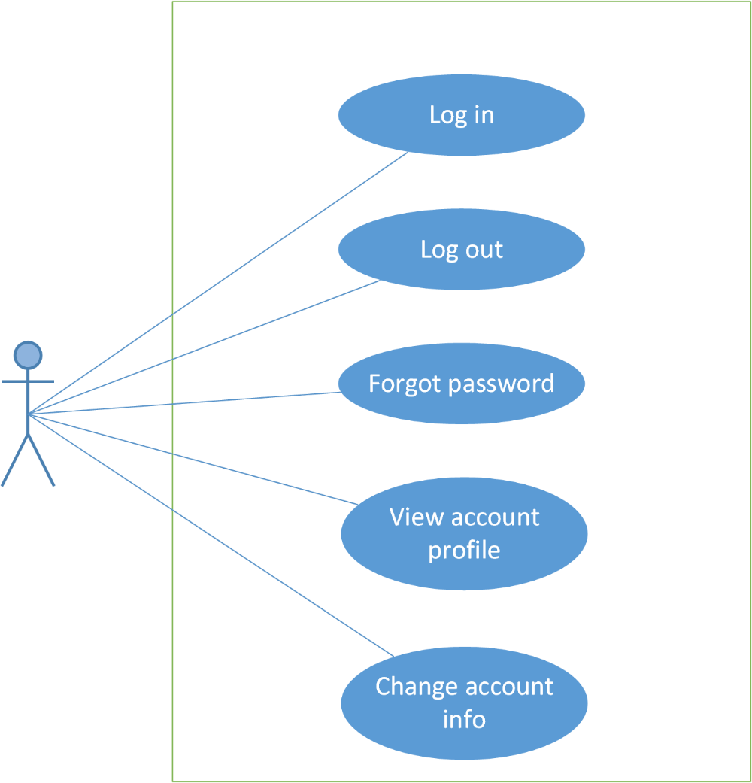

#### Use Case Specification

##### UC006: Login

**Main Success Scenario:**

|  |  |  |
| --- | --- | --- |
| **Step** | **User** | **System** |
| 1 | Enters Bus lover app | Displays Login screen |
| 2 | Inputs email and password, then taps “Đăng nhập” button | Validates information and logs user into app then moves to Dashboard screen. |

**Exceptions:**

|  |  |  |
| --- | --- | --- |
| **At Step** | **User** | **System** |
| 2 | Inputs into “Email”/ “Mật khẩu” field incorrectly then taps “Đăng nhập” button | Returns popup with Error message “Email hoặc mật khẩu không hợp lệ. Vui lòng nhập lại” |
| 2 | Leaves “Email”/ “Mật khẩu” field blank then taps “Đăng nhập” button | Returns popup with Error message “Vui lòng nhập đầy đủ thông tin. ” |

##### UC007: Log out

**Main Success Scenario:**

|  |  |  |
| --- | --- | --- |
| **Step** | **User** | **System** |
| 1 | Clicks on “Đăng xuất” button | Logs out and delete all remaining usage data |

##### UC008: Forgot password

**Main Success Scenario:**

|  |  |  |
| --- | --- | --- |
| **Step** | **User** | **System** |
| 1 | Enters Bus lover app | Displays Login screen |
| 2 | Inputs “Email” field then taps “Quên mật khẩu” button | System will send the password into your email |

**Exceptions:**

|  |  |  |
| --- | --- | --- |
| **At Step** | **User** | **System** |
| 2 | Inputs into “Email” field incorrectly then taps “Quên mật khẩu” button | Returns popup with Error message “Email không hợp lệ. Vui lòng nhập lại” |
| 2 | Leaves “Email” field blank then taps “Quên mật khẩu” button | Returns popup with Error message “Vui lòng nhập email để được nhận mật khẩu”. |

##### UC009: View account profile

**Main Success Scenario:**

|  |  |  |
| --- | --- | --- |
| **Step** | **User** | **System** |
| 1 | Enters Bus lover app | Displays Dashboard screen |
| 2 | Taps menu button | Displays menu |
| 3 | Taps Avatar icon | Displays Account info screen |

##### UC0010: Change account info

**Main Success Scenario:**

|  |  |  |
| --- | --- | --- |
| **Step** | **User** | **System** |
| 1 | Enters Bus lover app | Displays Dashboard screen |
| 2 | Taps menu button | Displays menu |
| 3 | Taps “Hình đại diện” icon | Displays Account info screen |
| 4 | Taps “Thay đổi” text | Displays Edit account info screen |
| 5 | Edits “Email”/”Mật khẩu”/”Hình đại diện” field then taps “Lưu” button | System will validate and save the changes, then move to Account info screen |

**Exceptions:**

|  |  |  |
| --- | --- | --- |
| **At Step** | **User** | **System** |
| 2 | Inputs into “Email”/ “Mật khẩu” field incorrectly then taps “Đăng nhập” button | Returns popup with Error message “Email hoặc mật khẩu không hợp lệ. Vui lòng nhập lại” |
| 2 | Leaves “Email”/ “Mật khẩu” field blank then taps “Đăng nhập” button | Returns popup with Error message “Vui lòng nhập đầy đủ thông tin. |

### Bus List Module

### Path Finder Module

#### Use Case Diagram

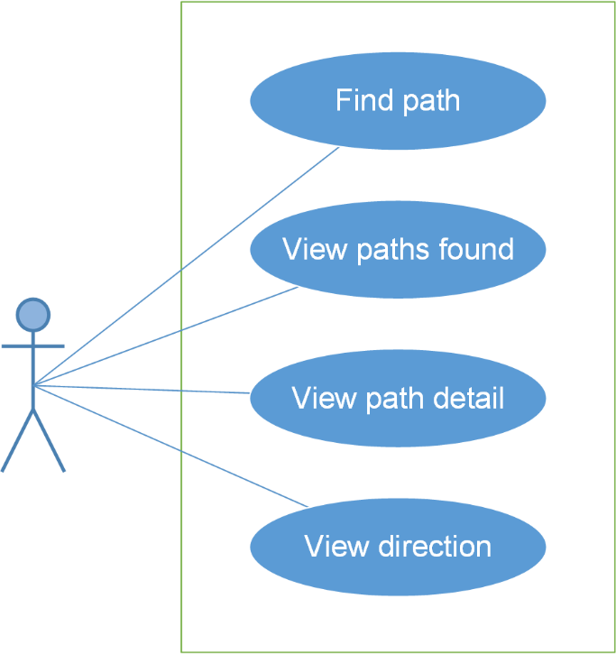

#### Use Case Specification

##### UC018: Find path

**Main Success Scenario:**

|  |  |  |
| --- | --- | --- |
| **Step** | **User** | **System** |
| 1 | Enters Bus lover app | Displays Dashboard screen |
| 2 | Taps Menu button then taps “Tìm đường” item. | Displays Path Finder screen |
| 3 | In “Bản đồ” tab, inputs departure into “Điểm đi” text field and destination into “Điểm đến” text field then taps Search button | Searches and displays found paths |

**Alternative Scenario:**

|  |  |  |
| --- | --- | --- |
| **At Step** | **User** | **System** |
| 3 | Inputs “Điểm đi” and “Điểm đến” text field then taps Revert direction button then taps Search button | Swaps 2 locations then searches and displays found paths |

|  |  |  |
| --- | --- | --- |
| **At Step** | **User** | **System** |
| 3 | In “Bản đồ” tab, taps Current Location button in order to input “Điểm đi”/ “Điểm đến” text field | Returns user’s current location into that text field |
| 4 | Inputs the other text field then taps Search button | Searches and displays found paths |

|  |  |  |
| --- | --- | --- |
| **At Step** | **User** | **System** |
| 3 | In “Bản đồ” tab, chooses locations on map in order to input “Điểm đi” and “Điểm đến” text field | Returns locations into “Điểm đi”/ “Điểm đến” text field |
| 4 | Taps Search button | Searches and displays found paths |

|  |  |  |
| --- | --- | --- |
| **At Step** | **User** | **System** |
| 3 | Taps “Lịch sử” tab | Displays places which were found before. |
| 4 | Chooses places for “Điểm đi”/ “Điểm đến” text field then taps Search button | Searches and displays found paths |

|  |  |  |
| --- | --- | --- |
| **At Step** | **User** | **System** |
| 3 | Taps “Yêu thích” tab | Displays favorite places which were set before. |
| 4 | Chooses places for “Điểm đi”/ “Điểm đến” text field then taps Search button | Searches and displays found paths |

**Exceptions:**

|  |  |  |
| --- | --- | --- |
| **At Step** | **User** | **System** |
| 3 | Inputs a place, which doesn’t exist, into “Điểm đi”/ “Điểm đến” text field then taps Search button | Returns popup with Error message “Điểm đi/ Điểm đến không tồn tại” |
| 3 | Leaves “Điểm đi”/ “Điểm đến” text field blank then taps Search button | Returns popup with Error message “Vui lòng nhập đầy đủ thông tin”. |
| 3 | Without Internet, inputs “Điểm đi” and “Điểm đến” text field then taps Search button | Returns popup with Error message “Thiết bị không kết nối mạng” |

##### UC019: View paths found

**Main Success Scenario:**

|  |  |  |
| --- | --- | --- |
| **Step** | **User** | **System** |
| 1 | Enters Path Finder screen, inputs information and taps Search button | * Searches and displays list of found paths in Paths found screen. * “Điểm đi”/ “Điểm đến” text field and Revert direction button will be disable. * A path will show the following information: total distance , walking distance, the number of exchange. |
| 2 | Taps “Quãng đường ngắn nhất” tab | Displays list paths found by filter: Shortest |

**Alternative Scenario:**

|  |  |  |
| --- | --- | --- |
| **At Step** | **User** | **System** |
| 2 | Taps “Chuyển tuyến ít nhất ” tab | Displays list paths found by filter: Least exchange |
| 2 | Taps “Đi bộ ít nhất” tab | Displays list paths found by filter: Least walk |

##### UC020: View path detail

**Main Success Scenario:**

|  |  |  |
| --- | --- | --- |
| **Step** | **User** | **System** |
| 1 | Enters Path Finder screen, inputs information and taps Search button | Searches and displays list of found paths in Paths found screen. |
| 2 | Chooses a path | Displays Path detail screen and shows the path chosen on the map. The bus which is nearest from the departure location will also be shown on the path draw. |
| 3 | Tap Bus icon | Shows how far from bus to the nearest bus-stop from departure location. |

**Alternative Scenario:**

|  |  |  |
| --- | --- | --- |
| **At Step** | **User** | **System** |
| 3 | Taps Arrow up button | Displays path details by the list: how far walk, which bus to get on,... |

##### UC021: View direction

**Main Success Scenario:**

|  |  |  |
| --- | --- | --- |
| **Step** | **User** | **System** |
| 1 | Enters Path Finder screen, inputs information and taps Search button | Searches and displays list of found paths in Paths found screen. |
| 2 | Chooses a path then taps Arrow up button | Displays Path detail screen |
| 3 | Taps Navigation button | Displays Directions button and shows step-by-step detailed direction according to the uer’s current location. |

### Reminder Module

#### Use Case Diagram

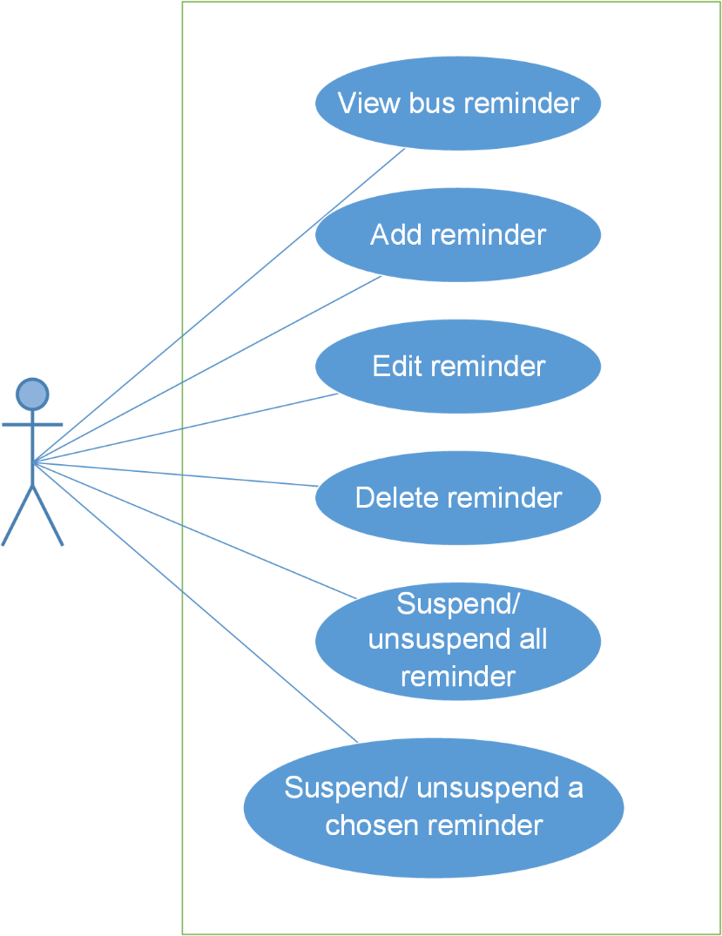

#### Use Case Specification

##### UC022: View bus reminder

**Main Success Scenario:**

|  |  |  |
| --- | --- | --- |
| **Step** | **User** | **System** |
| 1 | Enters Bus lover app | Displays Dashboard screen |
| 2 | Taps Menu button then taps “Nhắc nhở” item. | Displays Bus Reminder screen and shows list of reminder and the next reminder. If there isn’t any reminder, system will show message “Không có nhắc nhở nào” |

##### UC023: Add reminder

**Main Success Scenario:**

|  |  |  |
| --- | --- | --- |
| **Step** | **User** | **System** |
| 1 | Enters Bus Reminder screen and taps Add button | Displays Add Reminders screen |
| 2 | Inputs “Thời gian”, “Điểm đến” và “Lặp lại” text field then taps Add button | Displays Reminder Set Done screen |
| 3 | Confirms reminder by tapping Done button | Saves reminder and returns Bus Reminder screen. |

**Alternative Scenario:**

|  |  |  |
| --- | --- | --- |
| **At Step** | **User** | **System** |
| 3 | Taps Add button | Displays Add Reminders screen. |
| 4 | Inputs “Thời gian”, “Điểm đến” và “Lặp lại” text field then taps Add button | Displays Reminder Set Done screen |
| 5 | Confirms reminder by tapping Done button | Saves reminder and returns Bus Reminder screen. |

|  |  |  |
| --- | --- | --- |
| **At Step** | **User** | **System** |
| 1 | Enters Bus List screen and chooses a bus from list, then taps Add Reminder button | Displays Add Reminders screen. |

**Exceptions:**

|  |  |  |
| --- | --- | --- |
| **At Step** | **User** | **System** |
| 2 | Input a place which doesn’t exit into “Điểm đi” text field, then taps Add Reminder button. | Returns popup with Error message “Không tồn tại địa điểm này” |
| 2 | Leaves “Điểm đi” text field blank, then taps Add Reminder button | Returns popup with Error message “Vui lòng nhập đầy đủ thông tin.” |

##### UC024: Edit reminder

**Main Success Scenario:**

|  |  |  |
| --- | --- | --- |
| **Step** | **User** | **System** |
| 1 | Enters Bus Reminder screen and chooses a reminder from list | Displays Reminders Detail screen |
| 2 | Edits “Thời gian”/ “Điểm đến”/ “Lặp lại” text field then taps Add button | Displays Reminder Set Done screen |
| 3 | Confirms reminder by tapping Done button | Saves reminder and returns Bus Reminder screen. |

**Exceptions:**

|  |  |  |
| --- | --- | --- |
| **At Step** | **User** | **System** |
| 2 | Input a place which doesn’t exit into “Điểm đi” text field, then taps Add Reminder button. | Returns popup with Error message “Không tồn tại địa điểm này” |
| 2 | Leaves “Điểm đi” text field blank, then taps Add Reminder button | Returns popup with Error message “Vui lòng nhập đầy đủ thông tin.” |

##### UC025: Delete reminder

**Main Success Scenario:**

|  |  |  |
| --- | --- | --- |
| **Step** | **User** | **System** |
| 1 | Enters Bus Reminder screen and chooses a reminder from list | Displays Reminder Detail screen |
| 2 | Taps Delete button | Displays Confirm delete dialog. |
| 3 | Taps “Đồng ý” button | Deletes this reminder and comes back to Bus Reminder screen. |

**Alternative Scenario:**

|  |  |  |
| --- | --- | --- |
| **At Step** | **User** | **System** |
| 3 | Taps “Hủy” button | Comes back to Reminder Detail screen |

##### UC025: Delete reminder

**Main Success Scenario:**

|  |  |  |
| --- | --- | --- |
| **Step** | **User** | **System** |
| 1 | Enters Bus Reminder screen and chooses a reminder from list | Displays Reminder Detail screen |
| 2 | Taps Delete button | Displays Confirm delete dialog. |
| 3 | Taps “Đồng ý” button | Deletes this reminder and comes back to Bus Reminder screen. |

**Alternative Scenario:**

|  |  |  |
| --- | --- | --- |
| **At Step** | **User** | **System** |
| 3 | Taps “Hủy” button | Comes back to Reminder Detail screen |

##### UC026: Suspend/ Unsuspend all reminder

**Main Success Scenario:**

|  |  |  |
| --- | --- | --- |
| **Step** | **User** | **System** |
| 1 | Enters Bus Reminder screen then taps “Gạt để hoãn tất cả nhắc nhở” switch button | Suspends all reminders and hides them. |
| 2 | Taps “Gạt để hoãn tất cả nhắc nhở” switch button again. | Unsuspends all reminders and shows them. |

##### UC027: Suspend/ Unsuspend a chosen reminder

**Main Success Scenario:**

|  |  |  |
| --- | --- | --- |
| **Step** | **User** | **System** |
| 1 | Enters Bus Reminder screen then taps a “Hoãn nhắc nhở” switch button | Suspends a reminders. |
| 2 | Taps a “Hoãn nhắc nhở” switch button again | Unsuspends a reminders. |

### Track Module

#### Use Case Diagram

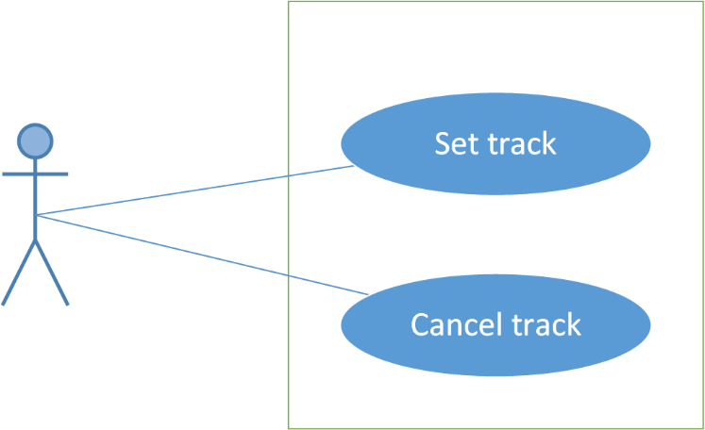

#### Use Case Specification

##### UC028: Set track

**Main Success Scenario:**

|  |  |  |
| --- | --- | --- |
| **Step** | **User** | **System** |
| 1 | Enters Bus List screen then chooses a bus item | Displays Bus Detail screen. |
| 2 | Taps Track button | Displays Set Track screen. |
| 3 | Chooses a bus-stop, where user wants to get off, in list then taps Track button | Displays Tracking screen and shows where user is in the journey. When the bus comes near the predefined stop, system will notify the user to leave. |

##### UC029: Cancel track

**Main Success Scenario:**

|  |  |  |
| --- | --- | --- |
| **Step** | **User** | **System** |
| 1 | Enters Bus List screen then chooses a bus item | Displays Bus Detail screen. |
| 2 | Taps Track button | Displays Set Track screen. |
| 3 | Chooses a bus-stop, where user wants to get off, in list then taps Track button | Displays Tracking screen and shows where user is in the journey |
| 4 | Taps “Hủy” button | Cancels tracking and comes back to Bus Detail |